**DAILY ONLINE ACTIVITIES SUMMARY**

|  |  |  |  |  |  |  |  |
| --- | --- | --- | --- | --- | --- | --- | --- |
| **Date:** | **6/06/2020** | | | | **Name:** | **Imran Khan** | |
| **Sem & Sec** | **8th A** | | | | **USN:** | **4AL16CS040** | |
| **Online Test Summary** | | | | | | | |
| **Subject** | | **IOT** | | | | | |
| **Max. Marks** | | **30** | | **Score** | | **30** | |
| **Certification Course Summary** | | | | | | | |
| **Course** | **Front-end devolopment** | | | | | | |
| **Certificate Provider** | | | **udemy** | **Duration** | | | **6 HOURS** |
| **Coding Challenges** | | | | | | | |
| Problem Statement:  Write a C Program to rotate the array by N position.. | | | | | | | |
| **Status: Solved** | | | | | | | |
| **Uploaded the report in Github** | | | | **yes** | | | |
| **If yes Repository name** | | | | **Imran040** | | | |
| **Uploaded the report in slack** | | | | **yes** | | | |

Online test details:

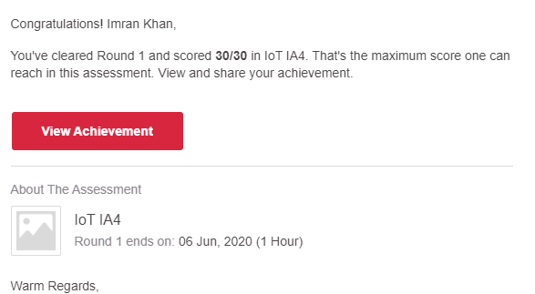

**Certification Course Details**:

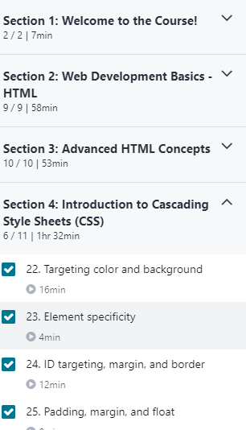

**Coding Challenges Details**:

**program1:**

|  |  |  |  |
| --- | --- | --- | --- |
|  | | | |
|  | |
| #include <stdio.h> | |
|  | | void shiftArr1Pos(int *arr1, int arrSize) |
|  | | { |
|  | | int i, temp; |
|  | | temp = arr1[0]; |
|  | | for(i = 0; i < arrSize-1; i++) |
|  | | { |
|  | | arr1[i] = arr1[i+1]; |
|  | | } |
|  | | arr1[i] = temp; |
|  | | } |
|  | | void arr1Rotate(int *arr1, int arrSize, int rotFrom) |
|  | | { |
|  | | int i; |
|  | | for(i = 0; i < rotFrom; i++) |
|  | | { |
|  | | shiftArr1Pos(arr1, arrSize); |
|  | | } |
|  | | return; |
|  | | } |
|  | | int main() |
|  | | { |
|  | | int arr1[] = {0,3,6,9,12,14,18,20,22,25,27}; |
|  | | int ctr = sizeof(arr1)/sizeof(arr1[0]); |
|  | | int i, n; |
|  | |  |
|  | | //---------- print original array ------------------------ |
|  | | printf("The given array is : "); |
|  | | for(i = 0; i < ctr; i++) |
|  | | { |
|  | | printf("%d ", arr1[i]); |
|  | | } |
|  | | printf("\n"); |
|  | |  |
|  | | printf("Enter the Position N from where you want to rotate: "); |
|  | | scanf("%d", &n); |
|  | |  |
|  | | //---------- print the values from 4th position ------------------------ |
|  | | printf("From 4th position the values of the array are : "); |
|  | | for(i = n; i < ctr; i++) |
|  | | { |
|  | | printf("%d ", arr1[i]); |
|  | | } |
|  | | printf("\n"); |
|  | | //---------- print the values before 4th position ------------------------ |
|  | | printf("Before 4th position the values of the array are : "); |
|  | | for(i = 0; i < n; i++) |
|  | | { |
|  | | printf("%d ", arr1[i]); |
|  | | } |
|  | | printf("\n"); |
|  | | //------------ after rotating the array -------------------- |
|  | | arr1Rotate(arr1, ctr, n); |
|  | | printf("\nAfter rotating from 4th position the array is: \n"); |
|  | | for(i = 0; i<ctr; i++) |
|  | | { |
|  | | printf("%d ", arr1[i]); |
|  | | } |
|  | | return 0; |
|  | | } |